DOMAIN 4 STUDY GUIDE
SSUSH15 The student will analyze the origins and impact of U.S. involvement in World War I.
a. Describe the movement from U.S. neutrality to engagement in World War I, with reference to unrestricted submarine warfare.
b. Explain the domestic impact of World War I, as reflected by the origins of the Great Migration, the Espionage Act, and socialist Eugene Debs.
c. Explain Wilson’s Fourteen Points and the proposed League of Nations.
d. Describe passage of the Eighteenth Amendment, establishing Prohibition, and the Nineteenth Amendment, establishing woman suffrage.
Explain America’s involvement in WWI. Make sure to include unrestricted submarine warfare!!!!!!!
NEUTRALITY ENGAGEMENT

Explain each of the following terms/figures and the impact they had on American’s lives at home.
Term | Explain/Describe | Impact
Domestic
Great Migration
Espionage Act
Eugene Debs
18th Amendment
19th Amendment
What was Wilson’s 14 Points? What was the League of Nations? What was the purpose behind both and why were they faulty or not concrete?
________________________________________________________________________________________________________________________________________________________________________________________________________________________________________________________________________________________________________________________________________________________________________

SSUSH16 The student will identify key developments in the aftermath of WW I.
a. Explain how rising communism and socialism in the United States led to the Red Scare and immigrant restriction.
b. Identify Henry Ford, mass production, and the automobile.
c. Describe the impact of radio and the movies.
d. Describe modern forms of cultural expression; include Louis Armstrong and the origins of jazz, Langston Hughes and the Harlem Renaissance, Irving Berlin, and Tin Pan Alley.

Explain each of the following and how they related to each other.

Communism Socialism

Red Scare

Immigration Restrictions

Describe each of the following and the impact they had.
Term | Describe/Define | Impact
Henry Ford
Mass Production
Automobile
Radio
Movies

Describe each of the following events or figures in American history following WWI.
Event/Figure | Description/Explanation | Impact in America
Louis Armstrong
Jazz
Langston Hughes
Harlem Renaissance
Irving Berlin
Tin Pan Alley

SSUSH17 The student will analyze the causes and consequences of the Great Depression.
a. Describe the causes, including overproduction, under-consumption, and stock market speculation that led to the stock market crash of 1929 and the Great Depression.
b. Explain factors (include over-farming and climate) that led to the Dust Bowl and the resulting movement and migration west.
c. Explain the social and political impact of widespread unemployment that resulted in developments such as Hoovervilles.

Causes of the Great Depression and Dust Bowl
Describe/Explain
Great Depression
Overproduction
Under consumption
Stock Market
Speculation
Stock Market Crash
Dust Bowl
Over-Farming
Climate

Consequences of the Great Depression and Dust Bowl
Describe/Explain
Great Depression
Social Impact
Political Impact
Unemployment
Hoovervilles
Dust Bowl
Movement and Migration

SSUSH18 The student will describe Franklin Roosevelt’s New Deal as a response to the depression and compare the ways governmental programs aided those in need.
a. Describe the creation of the Tennessee Valley Authority as a works program and as an effort to control the environment.
b. Explain the Wagner Act and the rise of industrial unionism.
c. Explain the passage of the Social Security Act as a part of the second New Deal.
d. Identify Eleanor Roosevelt as a symbol of social progress and women’s activism.
e. Identify the political challenges to Roosevelt’s domestic and international leadership; include the role of Huey Long, the “court packing bill,” and the Neutrality Act.

The 3 W’S of the New Deal…WHEN/WHAT/WHY!!!!!

 | WHEN | WHAT | WHY
Tennessee Valley Authority (TVA)
Wagner Act
Social Security Act (SSA)
Eleanor Roosevelt

Identify the Challenges that FDR faced when dealing with his New Deal programs.

Huey Long and “Share the Wealth” Program
“Court-Packing Bill”
Neutrality Act
A Phillip Randolph

SSUSH19 The student will identify the origins, major developments, and the domestic impact of World War II, especially the growth of the federal government.
a. Explain A. Philip Randolph’s proposed march on Washington, D.C., and President Franklin D. Roosevelt’s response.
b. Explain the Japanese attack on Pearl Harbor and the internment of Japanese- Americans, German-Americans, and Italian-Americans.
c. Explain major events; include the lend-lease program, the Battle of Midway, D-Day, and the fall of Berlin.
d. Describe war mobilization, as indicated by rationing, war-time conversion, and the role of women in war industries.
e. Describe the Manhattan Project at Los Alamos and the scientific, economic, and military implications of developing the atomic bomb.
f. Compare the geographic locations of the European Theater and the Pacific Theater and the difficulties the U.S. faced in delivering weapons, food, and medical supplies to troops.

Explain each of the events leading to US involvement in WWII, US involvement in WWII, and US end to WWII.
Event | Impact/Outcome
Pearl Harbor -
Lend-Lease Program -
War Mobilization -
Rationing -
War-Time Conversion -
Role of Women -
Battle of Midway -
D- Day -
Fall of Berlin -
Manhattan Project -

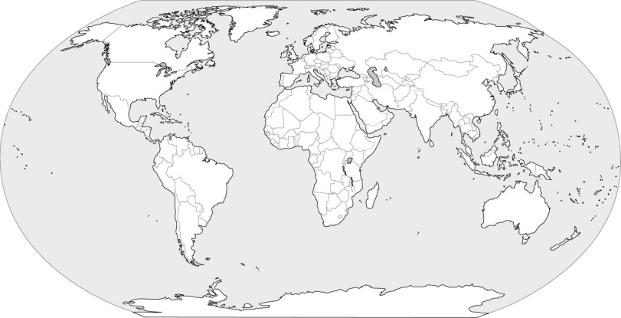
US European Pacific

How did the European Theater and the Pacific Theater and America’s fighting in Europe and Japan affect the war for America?
______________________________________________________________________________________________________________________________________________________________________________________________________________________________________________________________________________
__________________________________________________________________________________________

SSUSH20 The student will analyze the domestic and international impact of the Cold War on the United States.
a. Describe the creation of the Marshall Plan, U.S. commitment to Europe, the Truman Doctrine, and the origins and implications of the containment policy.
b. Explain the impact of the new communist regime in China and the outbreak of the Korean War and how these events contributed to the rise of Senator Joseph McCarthy.
c. Describe the Cuban Revolution, the Bay of Pigs, and the Cuban missile crisis.
d. Describe the Vietnam War, the Tet Offensive, and growing opposition to the war.
e. Explain the role of geography on the U.S. containment policy, the Korean War, the Bay of Pigs, the Cuban missile crisis, and the Vietnam War.

Following WWII
Policies | Explanation
Marshall Plan
Truman Doctrine
Containment

Communism at Home and Abroad
Event/Figure | Explanation | Impact
China
Korean War
Senator
Joseph McCarthy
Cuban Revolution
Bay of Pigs
Cuban Missile Crisis
Vietnam War
Tet Offensive

