Domain 3 Study Guide

SSUSH11 The student will describe the economic, social, and geographic impact of the growth of big business and technological innovations after Reconstruction.
a. Explain the impact of the railroads on other industries, such as steel, and on the organization of big business.
b. Describe the impact of the railroads in the development of the West; include the transcontinental railroad, and the use of Chinese labor.
c. Identify John D. Rockefeller and the Standard Oil Company and the rise of trusts and monopolies
d. Describe the inventions of Thomas Edison; include the electric light bulb, motion pictures, and the phonograph, and their impact on American life

Describe how the railroads impacted each of the following after reconstruction.
Impact
Steel Industry
Monopolies/Trust
Development of the West
Chinese

Identify the following monopolies:
Monopolies | People | Companies
Oil
Steel
Railroads

Describe each of Thomas Edison’s inventions and the impact they had on American life.
Invention | Use | Impact on American life
Electric light bulb
Motion Picture
Phonograph

SSUSH12 The student will analyze important consequences of American industrial growth.
a. Describe Ellis Island, the change in immigrants’ origins to southern and eastern Europe and the impact of this change on urban America.
b. Identify the American Federation of Labor and Samuel Gompers.
c. Describe the growth of the western population and its impact on Native Americans with reference to Sitting Bull and Wounded Knee.
d. Describe the 1894 Pullman strike as an example of industrial unrest.

Describe/Identify each of the following consequences on American industrial growth. Also include the impact it had on American life.
Consequences | Describe/Identify | Impact made on America
Ellis Island
New Immigrants
Urbanization
American Federation of Labor
Samuel Gompers
Western growth and Native Americans
Sitting Bull
Wounded Knee
Pullman Strike

SSUSH13 The student will identify major efforts to reform American society and politics in the Progressive Era.
a. Explain Upton Sinclair’s The Jungle and federal oversight of the meatpacking industry.
b. Identify Jane Addams and Hull House and describe the role of women in reform movements.
c. Describe the rise of Jim Crow, Plessy v. Ferguson, and the emergence of the NAACP.
d. Explain Ida Tarbell’s role as a muckraker.
e. Describe the significance of progressive reforms such as the initiative, recall, and referendum; direct election of senators; reform of labor laws; and efforts to improve living conditions for the poor in cities.
f. Describe the conservation movement and the development of national parks and forests; include the role of Theodore Roosevelt.

For each of the following Progressive Era figures or reform identify what they did and the impact or role it played in reform
movements.

Figure/Reform | Contribution/Development | Impact
Upton Sinclair
Jane Addams
Ida Tarbell
Theodore Roosevelt
NAACP
Plessey vs. Ferguson
Jim Crow
Initiative
Recall
Referendum
17th amendment
Efforts to improve living conditions
SSUSH14 The student will explain America’s evolving relationship with the world at the turn of the twentieth century.
a. Explain the Chinese Exclusion Act of 1882 and anti-Asian immigration sentiment on the west coast.
b. Describe the Spanish-American War, the war in the Philippines, and the debate over American expansionism.
c. Explain U.S. involvement in Latin America, as reflected by the Roosevelt Corollary to the Monroe Doctrine and the creation of the Panama Canal.

AS THE WORLD TURNS…..INTO THE 20TH CENTURY!!!!

Explain each of the following that led to the feelings American’s generated towards Asian immigrants

 | What is it? | What did it cause?
Chinese Exclusion Act of 1882
Anti-Asian Immigration Sentiment

Where, Why, and What….for each of the following complete the chart for where it took place, why it took place, and what happened as an outcome for each.

Event | Where | Why | What
Spanish-American War
War in the Philippines
American Expansionism at the turn of the 20th century

Monroe Doctrine Roosevelt Corollary

Panama Canal

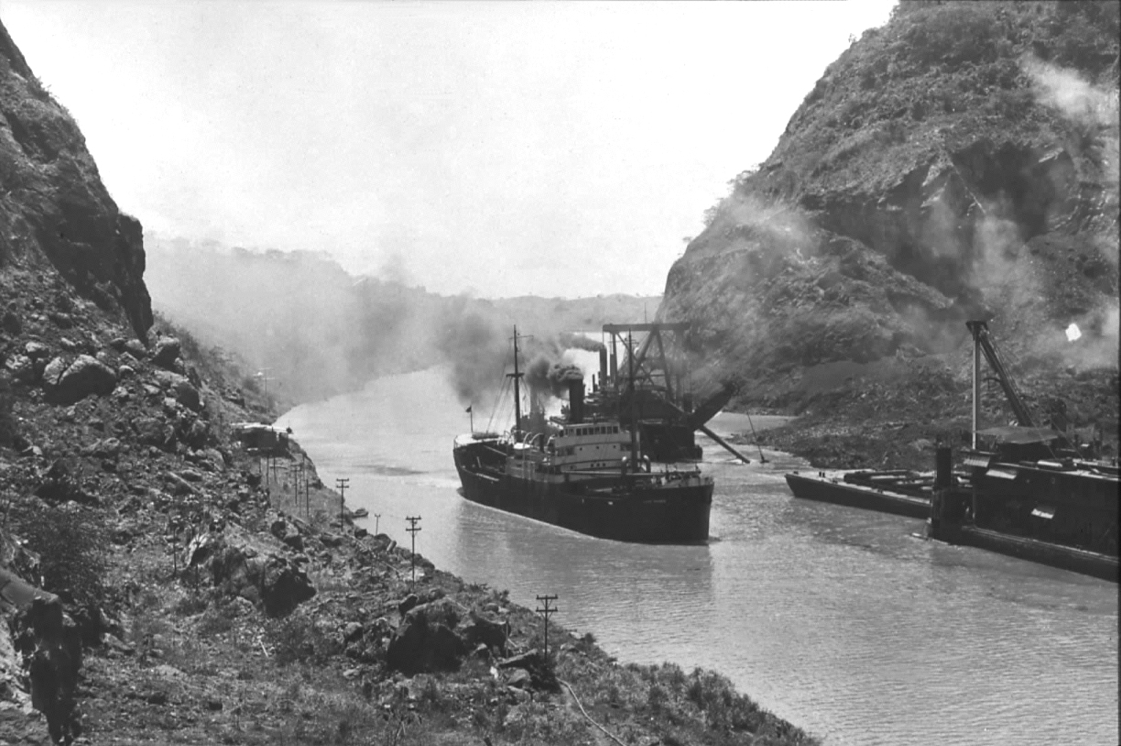
Explain the picture to the left. What is it and why was it built? Who built it and how did they gain control of the land to build it? What was the overall outcome for all countries involved?
_______________________________________________________________________________________________________________________________________________________________________________________________________________________________________________________________________________________________________________________________________________________________________________________________________________________________________________________________________

