DOMAIN 2 STUDY GUIDE
SSUSH6 The student will analyze the impact of territorial expansion and population growth and the impact of this growth in the early decades of the new nation.
a. Explain the Northwest Ordinance’s importance in the westward migration of Americans, and on slavery, public education, and the addition of new states.
b. Describe Jefferson’s diplomacy in obtaining the Louisiana Purchase from France and the territory’s exploration by Lewis and Clark.
c. Explain major reasons for the War of 1812 and the war’s significance on the development of a national identity.
d. Describe the construction of the Erie Canal, the rise of New York City, and the development of the nation’s infrastructure.
e. Describe the reasons for and importance of the Monroe Doctrine.

Using the pictures and chart, define the following territories and address the issues at hand for each territory.
 | Name of Area | Issues in the Area and how were the fixed of addressed.
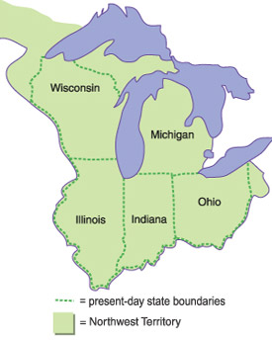 |  | 1)Westward Migration/Addition of New States:  2)Slavery:  3)Public Education:
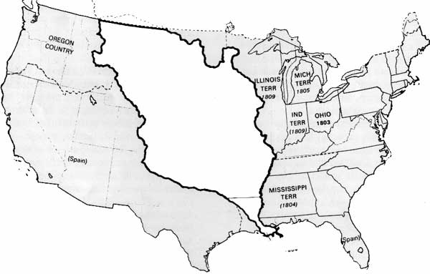 |  | 1)How did we obtain it:  3)Lewis and Clarke:

Complete the following chart for the War of 1812
Reasons For: | War of 1812 | Significance of:

Describe each of the following and how they helped to change the way of American life.
 | Describe it… | How did it help change America…
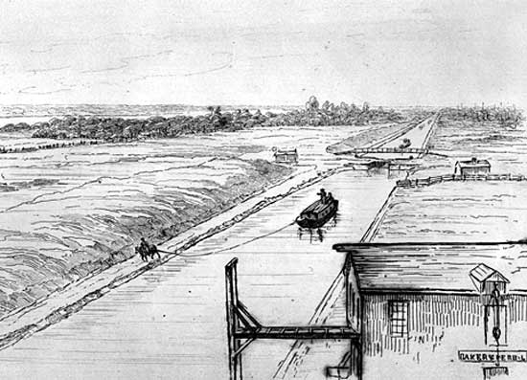
ERIE CANAL
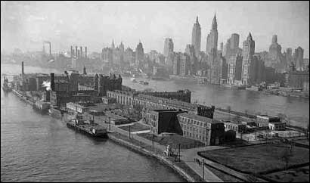
NYC

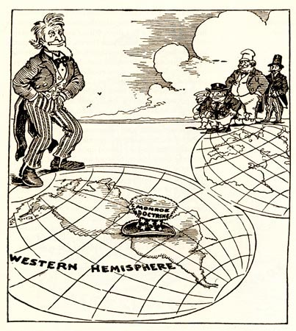
What does the following cartoon represent? What were the reasons for and importance of the cartoon’s representation?

________________________________________________________________________________________________________________________________________________________________________________________________________________________________________________________________________________________________________________________________________________________________________________________________________

SSUSH7 Students will explain the process of economic growth, its regional and national impact in the first half of the 19th century, and the different responses to it.
a. Explain the impact of the Industrial Revolution as seen in Eli Whitney’s invention of the cotton gin and his development of interchangeable parts for muskets.
b. Describe the westward growth of the United States; include the emerging concept of Manifest Destiny.
c. Describe reform movements, specifically temperance, abolitionism, and public school.
d. Explain women’s efforts to gain suffrage; include Elizabeth Cady Stanton and the Seneca Falls Conference.
e. Explain Jacksonian Democracy, expanding suffrage, the rise of popular political culture, and the development of American nationalism.

Label each of the following inventions of Eli Whitney, explain the impact they had, and explain what they said about American life during the industrial revolution:
Invention | Impact | What does it say about American life?
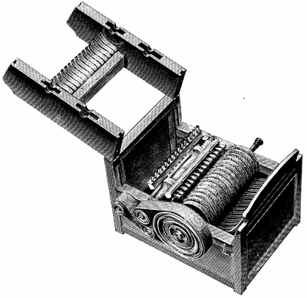
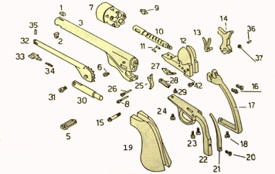

Complete the charts for each of the following reform movements:
Movement | Describe it… | Leaders involved… | Tactics used…
Temperance
Abolitionism
Public School
Women’s Suffrage

How did Andrew Jackson change or affect each of the following aspects during his political career?
Suffrage (voting) | Popular Political Culture | American Nationalism
Using the chart above, prior knowledge, notes, and even the books you have, explain Jacksonian Democracy…
____________________________________________________________________________________________________________________________________________________________________________________________________
__________________________________________________________________________________________________
NORTH VS. SOUTH
WHO, WHAT, WHEN, WHERE, WHY SCRAMMBLE
SSUSH8 The student will explain the relationship between growing north-south divisions and westward expansion.
What | Who | Why | When | Where
Slavery and Rebellion
a. Explain how slavery became a significant issue in American politics; include the slave rebellion of Nat Turner and the rise of abolitionism (William Lloyd Garrison, Frederick Douglass, and the Grimke sisters).

Missouri Compromise
b. Explain the Missouri Compromise and the issue of slavery in western states and territories.

Nullification Crisis
c. Describe the Nullification Crisis and the emergence of states’ rights ideology; include the role of John C. Calhoun and development of sectionalism.
War with Mexico & Wilmot Proviso
d. Describe the war with Mexico and the Wilmot Proviso.

Compromise of 1850
e. Explain how the Compromise of 1850 arose out of territorial expansion and population growth.
SSUSH9 The student will identify key events, issues, and individuals relating to the causes, course, and consequences of the Civil War.
a. Explain the Kansas-Nebraska Act, the failure of popular sovereignty, Dred Scott case, and John Brown’s Raid.
b. Describe President Lincoln’s efforts to preserve the Union as seen in his second inaugural address and the Gettysburg speech and in his use of emergency powers, such as his decision to suspend habeas corpus.
c. Describe the roles of Ulysses Grant, Robert E. Lee, “Stonewall” Jackson, William T. Sherman, and Jefferson Davis.
d. Explain the importance of Fort Sumter, Antietam, Vicksburg, Gettysburg, and the Battle for Atlanta and the impact of geography on these battles.
e. Describe the significance of the Emancipation Proclamation.
f. Explain the importance of the growing economic disparity between the North and the South through an examination of population, functioning railroads, and industrial output.

Causes of the Civil War: Explain each of the following!
Kansas-Nebraska Act
Failure of Popular Sovereignty
Dred Scott Case
John Brown’s Raid

Course of the Civil War:
Explain/Describe
Lincoln’s main goal during the Civil War.
Lincoln’s 2nd Inaugural Address
Gettysburg Address
Suspension of Habeas Corpus
Emancipation Proclamation

Person |  | Role played during the Civil War
Ulysses S. Grant
Robert E. Lee
Jefferson Davis
Abraham Lincoln
“Stonewall Jackson”
William T. Sherman
Battle | Importance of each battle during the Civil War
Fort Sumter
Antietam
Vicksburg
Gettysburg
Battle for Atlanta

Complete the following chart displaying the differences between the North and the South during the Civil War
 | North | South
Population
Functioning Railroads
Industrial Output
Military Tradition and Leadership
SSUSH10 The student will identify legal, political, and social dimensions of Reconstruction.
a. Compare and contrast Presidential Reconstruction with Radical Republican Reconstruction.
b. Explain efforts to redistribute land in the South among the former slaves and provide advanced education (Morehouse College) and describe the role of the Freedmen’s Bureau.
c. Describe the significance of the 13th, 14th, and 15th amendments.
d. Explain Black Codes, the Ku Klux Klan, and other forms of resistance to racial equality during Reconstruction.
e. Explain the impeachment of Andrew Johnson in relationship to Reconstruction.
f. Analyze how the presidential election of 1876 and the subsequent compromise of 1877 marked the end of Reconstruction.
Presidential Radical Republican

Identify and describe each of the following as for or against reconstruction:
 | Describe it… | For or against reconstruction…
Sharecropping/Tenant Farming
Freedman’s Bureau
13th Amendment
14th Amendment
15th Amendment
Black Codes
Ku Klux Klan
Morehouse College

Explain the impact each of the following had on Reconstruction following the Civil War…
Event | Impact on Reconstruction
Andrew Johnson’s impeachment
Presidential election of 1876
Compromise of 1877

